**SRS DOCUMENT FOR Vehicle Rental System**

**Purpose:**

System is designed for online vehicle reservation system with the help of tools through which customers can reserve available vehicles online prior to their expected pick-up date or time. This system allows the customer to book space for a group in the case of weddings or corporate meetings(Event management).

**Problem Statement:**

An AutoHub is a vehicle rental system that can be used to get vehicle on rent for a fee during a specified period. Getting a rental car helps people get around despite the fact they do not have access to their own personal vehicle or don't own a vehicle at all. The individual who needs a car must contact a rental car company and contract out for a vehicle. This system increases customer retention and simplify vehicle and staff management.

**Product Scope:**

This System allows Customer to rent a car or bike for travelling, function or personal use based on their availablity and requirement. Customer will be able to view available cars/bike, book a car/bike in available list of areas and may be able to cancel booking before 24 hours of booking date/time.

The System will be able to show live Business Operation statistics, trends through Customized dashboard for stakeholders.

**Functional Requirements:**

This section provides requirement overview of the system. Various functional modules that can be implemented by the system will be -3.1 Description

3.1.1 Registration : If customer wants to book the vehicle then he/she must be registered, unregistered user can’t go to the booking page.

3.1.2 Login: Customer logins to the system by entering valid user id and password for the shopping.

3.1.3 Changes to Booking: Changes to booking means the customer after login or registration can book or cancel booking of the vehicle from the booking list.

3.1.4 Payment: For customer there are many type of secure billing will be prepaid as debit or credit card .The security will provide by the third party like Pay-Pal etc.

3.1.5 Logout: After completion of booking or surf the product the customer will be logged out.

3.1.6 Report Generation: After all transaction the system can generate the portable document file (.pdf) and then sent one copy to the customer’s Email-address and another one for the system data base to calculate the monthly transaction.

3.2 Technical Issues: This system will work on client-server architecture. It will require an internet server and which will be able to run application. The system should support some commonly used browser such as IE etc.4.

3.3 Interface Requirement: Various interfaces for the product could be-

1. Login Page

2. Registration Form

3. There will be a screen displaying information about vehicle that the AutoHub having.

4. If the customers select the book button then another screen of booking list will be opened.

5.After confirming the list user will be redirected to payment page.

6.Booking confirmation page will be displayed.

3.4

Staff will be able to approve or reject request for booking vehicle

Staff will be to track and maintain stock of vehicles available for booking.

**Non-Functional Requirements:**

Security:

Registered Customer will be allowed to select/book an vehicle.

Each stakeholder will be able to access system through authentication process.

System will provide access to the content, operations using Role based security (Authorization) (Permissions based on Role)

Using SSL in all transactions which will be performed stakeholder.

It would protect confidential information shared by system to stake holder or Shared by stakeholder to system.

System will automatically log of all stakeholder after some time due to inactiveness.

System will block operations for inactive stakeholder and would redirect for authentication.

System will internally maintain secure communication channel between Servers ( Web Servers, App Servers, database Server)

Sensitive data will be always encrypted across communication.

Use proper firewall to protect servers from out side fishing, vulnerable attacks.

Reliability:

The system will backup business data on regular basis and recover in short time duration to keep system operational Continuous updates are maintained, continuous Administration is done to keep system operational.

During peak hours system will maintain same user experience by managing load balancing.

Availability:

The system should be available 24/7, with minimal downtime or maintenance issues.

Maintainability:

A Commercial database software will be used to maintain System data Persistence.

A readymade Web Server will be installed to host online Car rental system (Web Site) to manage server capabilities.

IT operations team will easily monitor and configure System using administrative tools provided by Servers.

Separate environment will be maintained for system for isolation in production, testing and development.

Portability:

PDA: Portable Device Application

System will provide portable User Interface ( HTML, CSS, JS,react) through which users will be able to access online Vehicle Rental System.

System can be deployed to single server, multi server, to any OS, Cloud (Azure or AWS or GCP)

Accessibility:

only registered customer will be able to book an vehicle after authentication.

Staff can reject or approve booking requests based on role provided.

BOD team will be able to view daily, weekly, monthly, annual business Growth through customized dashboard.

Durability:

System will retain customer booking list even though customer loose internet connection and join again.

System will maintain wishlist for customer. Customer will be able to add vehicle from wishlist and add to booking list whenever needed.

System will implement backup and recovery for retaining stake holders data, business operation data and business data over time.

Efficiency:

On Festival season, maximum number of users will place order, view products with same response time.

System will be able to manage all transactions with isolation.

Modularity:

System will designed and developed using reusable, independent or dependent business scenarios in the form of modules.

These modules will be loosely coupled and highly cohesive.

System will contain CRM, Inventory, booking list, booking done, payment processing, Delivery module, membership and Roles management modules.

Scalability:

System will be able to provide consistent user exeprience to stake holder as well as visitors irrespective of load.

Safety:

AutoHub will be secure from malicious attack, phishing.

AutoHub functionalilites are protected from outside with proper firewall configuration.

AutoHub will be always kept updated with latest anti virus software.

Bussiness data will be backed up periodically to ensure safty of data using increamental back up strategy.

Role based security will be applied for Application data and operations accessibility.

**Business Entities:**

Customer:

Customer's name, contact information, driver's license number(issue date more than 12 months), credit card information.

Vehicle:

Car's make, model, year, vehicle Type, vehicle registration number, location, insurance information.

Insurance:

Start date, End Date, Provider.

Booking:

Booking date, start date, end date, vehicle type, rental price, penalty, vehicle_id,customer_id

Payment:

Payment amount, payment method, and payment date.

Employee:

Name, job role, joinDate, contact information, salary, department.

ER Diagram:

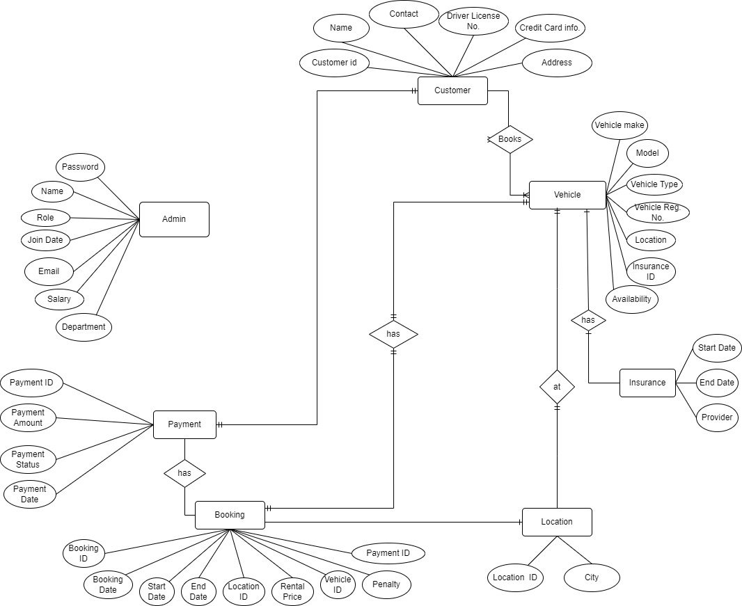

Use Case Diagram:

